**Input paper:** ENG19-3.1.1.10

**Input paper for the following Committee(s):** **Purpose of paper:**

(Select as appropriate)

ARM  ENG  PAP  Input

ENAV VTS  Information

**Agenda item** n.n

**Technical domain/ Task number** …………………………………

**Author(s)/Submitter(s)** ……Alwyn Williams…………

Correcting for Ambient Temperature in the Measurement of Lights

# Summary

In the most recent update to IALA Recommendation R0203 on the Terms of [Light] Measurement [1], some requirements for standard test conditions were laid out. The reason for this is to ensure consistency in the measurement parameters, and to minimise local effects on the measurement results. In the case of LED-based light sources, the ambient temperature can have a significant impact on the luminous flux output of the device. If the lights are measured in a controlled environment, then the uncertainty due to temperature variation can be minimised.

However, this is not always possible, and in this paper, we shall explore the phenomenon more closely, and propose a method of correcting measurements that were made outside the standard test conditions.

# LED Temperature Dependence

Like all electronic devices, LED’ performance is subject to the environment that it is operating in. Arguably, the largest limiting factor for the performance of LEDs is the temperature of the p-n junction. As a rule, the higher the temperature, the lower the luminous flux when operating at a constant fixed current. In practice, the amount that is varies by is dependent on the chemistry of the semiconductors and on the build of the LED device.

In this paper, datasheets from three LED manufacturers (Cree, Nichia and Lumileds) were used to obtain the luminous flux - temperature dependence data for their devices. The devices were filtered based on the dominant wavelength to determine if they were likely to meet the IALA colorimetry requirement for their colour. It is recognised that this is not a definitive method of determining the suitability of a colour LED for a marine AtoN application, but in lieu of accurate spectrum data, this was deemed acceptable to limit the analysis to the most likely acceptable candidates.

The raw data collected is shown in Figure 1, and it shows that there is a large variety in the temperature dependence on the luminous flux output. There is also some variation in the reference temperature (i.e. the temperature that is equal to 100%), so a means of standardising the data is needed. The line colour represents the IALA Recommendation R0201 [2] colour of the LED, with white being represented by black. Green represents the Green B region as no Green A region-compliant LEDs were found in the range of LEDs used in this study.

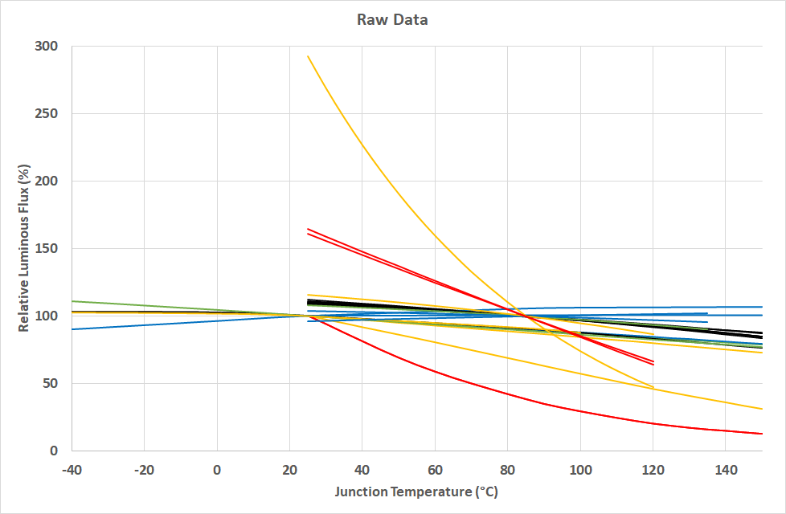

Figure 1 – Raw data digitised from LED manufacturer datasheets. The lines have been colour-coded to represent the IALA Recommendation R0201 colour of the LED (white is represented by black).

# Analysis of the Data

To analyse the data, we will consider the approach given in CIE International Standard S 025/E:2015 [3] and CIE Technical Report 198-SP1.1:2011 [4].

We will assume that the relationship between the relative luminous flux and the temperature is linear to simplify the process. As can be seen from Figure 1, this might be an oversimplification where the relationship for some LED devices is certainly not linear. However, the difficulty in the measurement process is that the absolute junction temperature is unknown. So, a non-linear solution that requires the absolute junction temperature to determine the correction is not a viable approach.

The basis of the analysis is the following linear equation:

$$Φ_{T}=Φ_{T_{0}}\left(1+α∆T\right)$$

Where $Φ_{T}$ the (relative) luminous flux at the temperature $T$,

$Φ_{T_{0}}$ is the (relative) luminous flux at the reference temperature $T_{0}$,

$α$ is the relative temperature coefficient (in °C-1),

is the temperature difference ($∆T=T−T_{0}$).

We will use this equation to calculate $α$ for all the devices and all temperatures that we have data for, and the results are shown in Figure 2. This figure shows that many of the devices have constant value for $α$ over a wide temperature range, implying that the linear model is a good fit to many of the LED devices. There are exceptions, most notably a couple of the yellow and red LEDs show a strong temperature coefficient dependence on the absolute junction temperature. In addition, the yellow/amber LEDs have quite a marked difference in values between devices, which makes the generalisation more unreliable for such devices.

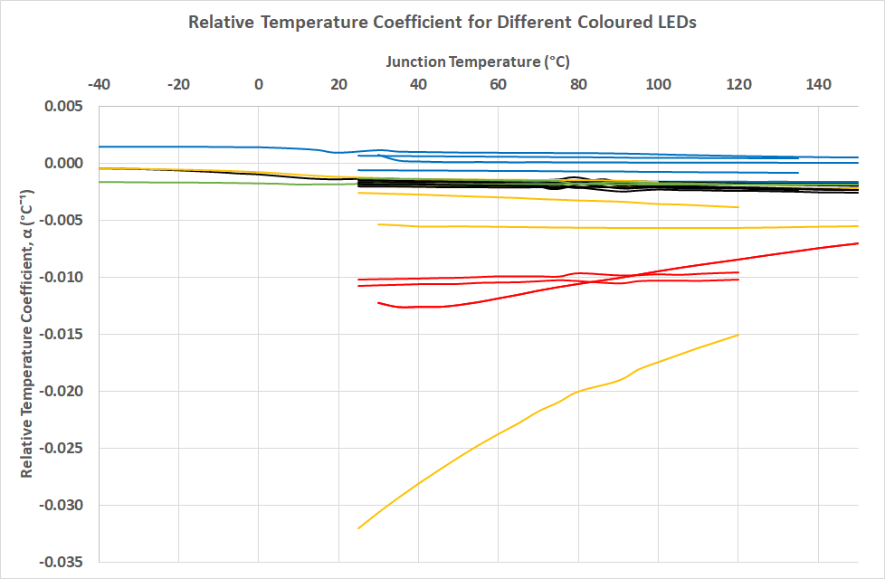

Figure 2 - Relative temperature coefficient of the LEDs in the study. The lines have been colour-coded to represent the colour of the LED (white is represented by black).

Nevertheless, since we have the values for the relative temperature coefficient across all devices and absolute junction temperature, we can average all the values of the same colour to get relative temperature coefficient based on the colour. The result of the analysis is shown below in Table 1.

Table 1 - Relative temperature coefficients for LEDs exhibiting different IALA Colours

|  |  |  |  |
| --- | --- | --- | --- |
| **IALA Colour** | **Sample Count** | **Mean α**  **(°C-1)** | **Standard Deviation of α**  **(°C-1)** |
| **White** | 8 | -0.00184 | 0.00027 |
| **Red** | 4 | -0.01008 | 0.00141 |
| **Yellow** | 5 | -0.00612 | 0.00212 |
| **Green A** | 0 |  |  |
| **Green B** | 3 | -0.00172 | 0.00012 |
| **Blue** | 5 | -0.00002 | 0.00019 |

The table shows that red is the most affected by temperature with the highest magnitude temperature coefficient, followed by yellow. Blue is so close to zero that it could practically be considered as having no temperature dependence (at least over the absolute junction temperatures considered in this study). Unfortunately, no LED devices that meet the Green A region have been found yet.

There is uncertainty associated with using this approach, and the standard deviation column of Table 1 can be used to determine the standard uncertainty of the correction factor which would be considered in the uncertainty budget of the measurement process.

# Correcting for Temperature in Measurements

In this section, we can consider how these values can be used to correct a light intensity measurement to meet the standard test conditions in IALA Recommendation R0203.

We will reuse the equation in Section 3 to show how the correction is applied with the luminous flux replaced by luminous intensity. The reference temperature is now $T_{0}=$ 25 °C. Thus,

$$I_{25}=\frac{I_{T}}{\left(1+α\left[T−25\right]\right)}$$

Where $I_{T}$ is the luminous intensity as measured (in cd),

$I_{25}$ is the corrected luminous intensity under standard test conditions where $T_{0}=$ 25 °C (in cd),

$T$ is the ambient temperature of the measurement environment at the time of measurement (in °C),

$α$ is the appropriate relative temperature coefficient from Table 1 (in °C-1).

## Measurement Uncertainty

To determine the uncertainty of the technique, we shall consider the approach given in [3], [4]. It can be summarised as:

$$u^{2}\left(I_{25}\right)=u^{2}\left(I_{T}\right){\left(1+α∆T\right)}^{2}+I_{T}^{2}\left\{u^{2}\left(α\right){\left(∆T\right)}^{2}+u^{2}\left(∆T\right)\left[α^{2}+u^{2}\left(α\right)\right]\right\}$$

Where $u^{2}\left(I_{25}\right)$ is the variance of the correct intensity,

$u^{2}\left(I_{T}\right)$ is the variance in the recorded intensity,

$u^{2}\left(α\right)$ is the variance of the relative temperature coefficient, and

$u^{2}\left(∆T\right)$ is the variance of the difference between the ambient temperature of the measurement and 25 °C (the standard test condition temperature).

The value of $u^{2}\left(α\right)$ can be obtained by squaring the standard deviation value of the appropriate relative temperature coefficient as given in Table 1. This would seem to be the most sensible approach as it will consider the variation between LED devices and absolute junction temperatures.

The value for $u^{2}\left(∆T\right)$ requires further consideration. Recall that $∆T=T−25$, where T is the ambient temperature of the measurement environment. In this arrangement, the value of 25 °C is a constant defined by the standard test conditions requirement: it does not have any uncertainty. By applying a standard equation for the uncertainty of uncorrelated summed random variables [5], we can state that:

$$u^{2}\left(∆T\right)=u^{2}\left(T\right)$$

Where $u^{2}\left(T\right)$ is the variance in the measurement ambient temperature.

## Example

Consider a red LED lantern measured in an environment with an ambient temperature of 30 ± 1 °C ($k=2$). The luminous intensity was recorded to be 100.0 ± 3.0 cd ($k=2$).

To get the expected luminous intensity under standard test conditions for a red LED, let $T=$ 30 °C and  °C-1 (from Table 1). So,

$$I_{25}=\frac{100}{\left(1−0.01008⋅\left[30−25\right]\right)}$$

$$I_{25}=\frac{100}{0.9496}$$

$I_{25}=105.3$ cd

We shall now consider the uncertainty of this value. The uncertainty in the temperature and luminous intensity are given in expanded uncertainty terms, so this needs to be converted into the standard uncertainty by dividing by the value of $k$. In addition, we will use the standard deviation from Table 1 for the standard uncertainty of the relative temperature coefficient. Thus,

cd

°C

°C-1

We now have all the information to calculate the uncertainty in the corrected luminous intensity of the light:

$$u^{2}\left(I_{25}\right)={\left(1.5\right)}^{2}{\left(1−0.01008⋅\left[30−25\right]\right)}^{2}+{\left(100\right)}^{2}\left\{{\left(0.00141\right)}^{2}{\left(30−25\right)}^{2}+{\left(0.5\right)}^{2}\left[{\left(−0.01008\right)}^{2}+{\left(0.00141\right)}^{2}\right]\right\}$$

$$u^{2}\left(I_{25}\right)=2.0289+0.7560=2.7849$$

$u\left(I_{25}\right)=1.67$ cd

The reported light intensity of the measured unit under standard test conditions is 105.3 ± 3.3 cd ($k=2$).

# Conclusions

The revised IALA Recommendation R0203 sets out standard test conditions, which an environment-control laboratory should be able to maintain during a light measurement. However, carrying out light measurement in this way is not always possible, especially for lights that require a large distance between the device being tested and the measurement equipment, or if it is being conducted outside. It is also well-known that the performance of LEDs relies on the absolute junction temperature, and that the variation in luminous flux can be considerable.

In this paper, we examined the variability of LED devices with temperature and grouped them by the IALA colour regions as set out in IALA Recommendation R0201. Most of the colours can be well-generalised by a relative temperature coefficient that described how the LED performance is expected to change with a given change in temperature.

The process outlined in this paper demonstrates an approach to dealing with the problem of not being able to measure lights under standard test conditions, including the calculation of the measurement uncertainty. Further, this is an approach recommended and cited by CIE in their documents [3], [4].

It is recommended that further work is needed to identify more LED devices to ensure that the calculated relative temperature coefficients and their variances accurately reflect the performance of LEDs that potentially are used in marine AtoN lights. Therefore, AtoN light manufacturers are encouraged to notify the author of this paper of which LED devices that they use in their products to ensure that the dataset is as complete as possible. This will result in a second paper to propose relative temperature coefficients to be used by IALA members in future measurements.

# References

[1] *Recommendation R0203: Marine Signal Lights - Terms of Measurement*, 2.0. Paris: IALA, 2022.

[2] *Recommendation R0201: Marine Signal Lights - Colours*. Paris: IALA, 2017.

[3] CIE TC 2-71, *CIE S 025/E:2015 Test Method for LED Lamps, LED Luminaires and LED Modules*, Vienna, Austria., 2015.

[4] CIE, ‘CIE 198-SP1.1:2011 Determination of Measurement Uncertainties in Photometry Supplement 1: Modules and Examples for the Determination of Measurement Uncertainties; Part 1: Modules for the Construction of Measurement Equations’, International Commission on Illumination (CIE), Vienna, Austria, 2011.

[5] I. Farrance and R. Frenkel, ‘Uncertainty of Measurement: A Review of the Rules for Calculating Uncertainty Components through Functional Relationships.’, *Clin. Biochem. Rev.*, vol. 33, no. 2, pp. 49–75, May 2012.

# Action requested of the Committee

The committee is kindly requested to review the approach given in this paper to the issue of dealing with measurements made outside the acceptable temperature range of the standard test conditions given in IALA Recommendation R0203. If acceptable, it should be included in the revised guideline on how light measurements should be carried out.

In addition, the author would be very grateful if marine AtoN light manufacturers are able to let him know (in confidence) what LED models they use in their products. This will help to ensure that the relative temperature coefficients are broadly representative of LEDs being used by IALA members.